Blogs

One of Our Projects: JLC and Ronald McDonald House

Ronald McDonald House keeps families together when it matters most. By providing a home away from home for families of hospitalized children dealing with complex medical needs, Ronald McDonald House serves the families and children of our community.

Members of our Junior League community continue to act on the Junior League mission to promote volunteerism and improve the community. The opportunity to volunteer at Ronald McDonald house was a wonderful experience for some of our fellow Junior League women.

On February 1st, 18 of our JLC members prepped, cooked, and served a homemade and healthy dinner for 75 people at the Ronald McDonald House. Through Ronald McDonald’s “Meals from the Heart” program, our JLC members were able to experience the direct impact this meal had on the guests of the house. Chatting with and getting to know the families and children was a rewarding and heart-warming experience. Our JLC women provided smiles along with their lovingly made meal to make the last meal of the day a fun and heartfelt way for all participants to close their day. One JLC member stated, “It was wonderful to be able to show some Chicago Hospitality to individuals that were away from home and having a loved one receive care at Lurie Children’s Hospital.”

So what tasty meal did our JLC women prepare? The meal was a large one! Baked breaded chicken breasts, caesar salad, a baked potato bar (all fixings included, of course!), tasty rolls, tea and lemonade to drink, and a healthy but certainly tasty fruit salad for dessert.

Our JLC ladies put their teamwork into action as they broke off into teams to complete all the tasks needed to get everything prepared and cooked within an hour and a half before it was dinner time. Way to go ladies!

Some of the patients receiving outpatient care were able to enjoy the meal too. One of many of the heart-warming stories shared from the evening was of a young boy who gave all of the JLC member’s high-fives after he enjoyed his meal. The excitement and love that filled the dining room that night was truly memorable, so many happy faces and big smiles!

After dinner, the staff at Ronald McDonald House gave our members a tour of the beautiful facility. Our members were excited to learn that the House is the **Largest Ronald McDonald House in the World!**

The event provided not only a way for the league to give back to the area in which league members live, but also allowed the league members to get to know one another. The night was quite the success, and our JLC ladies look forward to future opportunities to work with Ronald McDonald House and the families and children that call it a home away from home.

We look forward to more smiles and more fun times in partnering with Ronald McDonald House!

By: Elise Houren, Topics and Trends Committee Member

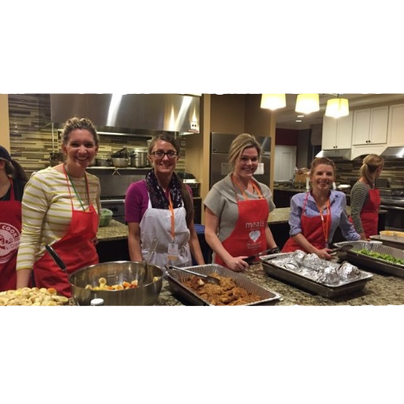

How to Succeed in the Junior League

Whether you’re a born leader or one in training, the Junior League of Chicago provides an unparalleled platform to hone your leadership skills. As stated in our [values](https://www.jlchicago.org/home/about/), “the JLC provides training in a safe environment for responsible and thoughtful risk-taking.”

Combined with the range of committees, outreach programs, and community partnerships, the opportunities abound for members to expand their skills in a sensitive and respectful environment.

The qualities of a JLC leader are similar to those of any organization (vision, dedication, assertiveness, etc.) but since the JLC is a volunteer organization, there are a few other important qualities to add to your repertoire. **Laura Southwick**, a former Annual Fund Chair, suggests strengthening five leadership attributes key to becoming a successful JLC leader.

1) **Enthusiasm**: Take an active interest in the League in general, the committee you are on, and the goals you set out to accomplish throughout the year.

2) **Development**: The best source to develop new leaders in the League is our current leaders. If you’re currently in a leadership position, keep an eye out for women who show the talents, skills, drive, and excitement for leadership.

3) **Involvement**: Get involved with general events of the League. Attend fundraising events, go to general meetings, or buy raffle tickets at events. This is your organization — own it!

4) **Contribution**: Support the League beyond dues. Contribute to the annual fund, buy tickets for fundraising events, and leverage outside relationships to help solicit additional revenue opportunities.

5) **Communication & Listening**: League leaders are liaisons between committees and the League’s management. This is key for information to flow freely, members to feel understood, and to cultivate ideas, thus allowing the League to make forward progress. Open communication will also keep your committee engaged and excited about the JLC.

Whether you’re taking on a new role or figuring out how to reach your committee’s goals, be fearless in knowing that you have the support of hundreds of other like-minded women. The League will stand with you as you strengthen your skills and lead the way.

*By Melissa Bueninck with contributions from Erin (Bonnivier) White, Originally Published 2008*

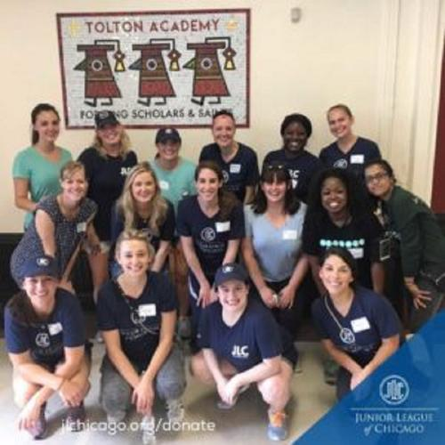

Project Spotlight: Helping Chicago Girls Grow into Successful Leaders

**Girls Grow into Successful Leaders:** The JLC’s Teen Exodus program, a unique opportunity for Chicago middle- and high-schoolers in the Chicagoland area, was born out of a partnership with Chicago Youth Programs (CYP).  Teen girls in grades 7 to 12 apply to JLC’s Teen Exodus program and, if accepted, meet every Saturday with Teen Exodus committee members. Alex Doctor and Sarah Lux, chairs of the Teen Exodus program, do their best to offer the young ladies experiences to which they may not typically have access, including self defense classes, cultural and art museum trips, and educational programs focused on life skills. The teens get to lunch with their cohorts and JLC volunteers as well.

In communities where just one-third of youths graduate from high school, more than 90 percent of Chicago Youth Programs participants not only stay in school, but also avoid criminal conviction, teen parenthood and gangs, [according to the organization](http://chicagoyouthprograms.org/outcomes/). The youths are also less likely to sustain injuries due to the use of drugs or violent activities, CYP reports. From 2014 to 2016, every CYP high school graduate moved on to institutions of higher education. Putting in over 700 volunteer hours each year, JLC’s Teen Exodus committee plans some 25 events with CYP to provide safe and healthy mentorship and opportunities to 30 young women every school year.

The opportunity to mentor these young women is not about logging hours; its about making their time together count. JLC Teen Exodus committee co-chairs Alex and Sarah discussed the importance of forging trust-filled relationships with the young ladies, which starts with the basics, like memorizing the girls’ names. The co-chairs say developing trusting relationships with the teens offers the youths an opportunity to gain a confidant should they need someone to talk to outside of their home and school environments.

Teen Exodus participants often return to the program each school year. As a result, JLC mentors watch as the young girls grow from 7th graders to high school seniors ready to enter the world as adults.

“Getting to create strong one-on-one meaningful relationships with them and seeing the girls really appreciate and benefit from the programs” is what makes the program so special, according to Sarah. Many of the participants in Teen Exodus grow up to be natural leaders within the program, taking on responsibility and helping to care for the younger girls in the program.

Many of the Teen Exodus committee members foster long-term relationships with the teens that goes beyond the programs, with some JLCers attending the students’ basketball games and ballet performances. Seeing the girls mature, take their SAT’s and become college applicants is a special experience for JLC Teen Exodus committee members. After graduation, some JLCers and former Teen Exodus participants continue to stay in touch, meeting up for coffee and remaining involved in each other’s lives well after their time together in the program has ended.

For more about Teen Exodus and other JLC volunteer programs, visit our [Community Projects page](https://www.jlchicago.org/community-impact/chicago/).

*By Sierra Powel-Smith, 2017-2018 Topics & Trends staff member*



Who We Are

For more than a century, The Junior League has empowered women to lead. We’ve worked with leaders who’ve set bold goals, opened their circles, disrupted convention and changed the conversation for the betterment of civil society. The Junior League of Chicago (JLC) partners with community organizations, non-profits, and schools, allowing them to better achieve their mission.

The Junior League of Chicago is dedicated to strengthening and transforming our community through effective action and leadership of well-trained volunteers.

Through collaboration and community engagement, we seek to remove the many barriers to success which limit the ability of disadvantaged children and families to improve themselves and their community.

Each year, The Junior League of Chicago donates over 125,000 volunteer hours to community agencies and programs that support child welfare and education.

In addition, the JLC raises thousands of dollars each year to fund our 12 community projects. For more than a century, the JLC has diligently worked to empower at-risk families—especially women and girls—through hands-on mentoring, advocacy and education.

Learn about how the Junior League of Chicago builds better, healthier communities through our [Community Projects](https://www.jlchicago.org/home/about/community-projects/), [Advocacy Initiatives](https://www.jlchicago.org/community-impact/advocacy/), and [Leadership Training](https://www.jlchicago.org/community-impact/leadership-training).

The Junior League of Chicago partners with organizations throughout the Chicagoland area to support at-risk women and children. If you would like to have your organization considered for a future Junior League Chicago Community project or volunteer event, [*please tell us about your organization.*](https://members.jlchicago.org/?nd=vms_public_form&form_id=7) A JLC member will reach out to you within 72 hours of your submission. Thank you.

